# Lab: Inheritance

Problems for exercises and homework for the ["C# OOP Basics" course @ SoftUni](https://softuni.bg/courses/csharp-oop-basics)".

You can check your solutions here: <https://judge.softuni.bg/Contests/679/Inheritance-Lab>.

# Part I: Inheritance

## Single Inheritance

Create two classes named Animal and Dog.

Animal with a single public method Eat() that prints: **"eating…"**

Dog with a single public method Bark() that prints: **"barking…"**

Dog should inherit from Animal.

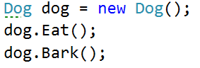

### Hints

Use the **: operator** to build a hierarchy

## Multiple Inheritance

Create three classes named Animal, Dog and Puppy.

Animal with a single public method Eat() that prints: **"eating…"**

Dog with a single public method Bark() that prints: **"barking…"**

Puppy with a single public method Weep() that prints: **"****weeping…"**

Dog should inherit from Animal. Puppy should inherit from Dog.

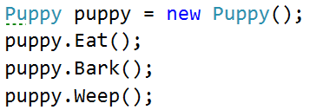

## Hierarchical Inheritance

Create three classes named Animal, Dog and Cat.

Animal with a single public method Eat() that prints: **"eating…"**

Dog with a single public method Bark() that prints: **"barking…"**

Cat with a single public method Meow() that prints: **"meowing…"**

Dog and Cat should inherit from Animal.

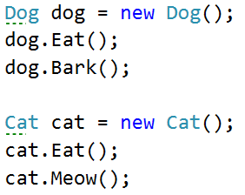

# Part II: Reusing Classes

## Random List

Create a RandomList class that has all the functionality of List<string>.

Add additional function that **returns** and **removes** a random element from the list.

* Public method: RandomString(): string

## Stack of Strings

Create a class StackOfStrings which can store only strings and has the following functionality:

* Private field: **data: List<string>**
* Public method: Push(string item): void
* Public method: Pop(): string
* Public method: Peek(): string
* Public method: IsEmpty(): bool

Use composition/delegation in order to have a field in which to store the stack's data